Практическая работа №2

Тема: «Разработка модульной структуры проекта

(диаграммы модулей)»

Цель: научиться разрабатывать Windows Forms приложения в Visual

Studio и разрабатывать в них несколько функциональных модулей.

Листинг кода

using System;

using System.Data;

using System.Data.SqlClient;

using System.IO;

using System.Windows.Forms;

namespace SkladApp

{

public partial class Sklad : Form

{

private string connectionString = @"Data Source=DESKTOP-3CVUA48\SQLEXPRESS;Initial Catalog=sklad;Integrated Security=True";

public Sklad()

{

InitializeComponent();

LoadProducts();

}

private void LoadProducts()

{

try

{

using (SqlConnection connection = new SqlConnection(connectionString))

{

string query = "SELECT * FROM products";

SqlDataAdapter adapter = new SqlDataAdapter(query, connection);

DataTable table = new DataTable();

adapter.Fill(table);

dataGridViewProducts.DataSource = table;

}

}

catch (Exception ex)

{

MessageBox.Show($"Ошибка загрузки данных: {ex.Message}");

}

}

// Модуль 1: Управление продуктами

private void btnUpdate_Click(object sender, EventArgs e)

{

if (dataGridViewProducts.CurrentRow != null)

{

try

{

int id = Convert.ToInt32(dataGridViewProducts.CurrentRow.Cells["id"].Value);

string name = txtName.Text;

int stillage = Convert.ToInt32(txtStillage.Text);

int cell = Convert.ToInt32(txtCell.Text);

int quantity = Convert.ToInt32(txtQuantity.Text);

using (SqlConnection connection = new SqlConnection(connectionString))

{

string query = "UPDATE products SET name=@name, stillage=@stillage, cell=@cell, quantity=@quantity WHERE id=@id";

SqlCommand command = new SqlCommand(query, connection);

command.Parameters.AddWithValue("@name", name);

command.Parameters.AddWithValue("@stillage", stillage);

command.Parameters.AddWithValue("@cell", cell);

command.Parameters.AddWithValue("@quantity", quantity);

command.Parameters.AddWithValue("@id", id);

connection.Open();

command.ExecuteNonQuery();

}

LoadProducts();

}

catch (Exception ex)

{

MessageBox.Show($"Ошибка обновления: {ex.Message}");

}

}

}

private void btnDelete_Click(object sender, EventArgs e)

{

if (dataGridViewProducts.CurrentRow != null)

{

try

{

int id = Convert.ToInt32(dataGridViewProducts.CurrentRow.Cells["id"].Value);

using (SqlConnection connection = new SqlConnection(connectionString))

{

string query = "DELETE FROM products WHERE id=@id";

SqlCommand command = new SqlCommand(query, connection);

command.Parameters.AddWithValue("@id", id);

connection.Open();

command.ExecuteNonQuery();

}

LoadProducts();

}

catch (Exception ex)

{

MessageBox.Show($"Ошибка удаления: {ex.Message}");

}

}

}

private void btnSaveToFile_Click(object sender, EventArgs e)

{

using (SaveFileDialog saveFileDialog = new SaveFileDialog())

{

saveFileDialog.Filter = "Text files (*.txt)|*.txt";

if (saveFileDialog.ShowDialog() == DialogResult.OK)

{

using (StreamWriter writer = new StreamWriter(saveFileDialog.FileName))

{

foreach (DataGridViewRow row in dataGridViewProducts.Rows)

{

if (!row.IsNewRow)

{

writer.WriteLine($"{row.Cells["id"].Value}\t{row.Cells["name"].Value}\t{row.Cells["stillage"].Value}\t{row.Cells["cell"].Value}\t{row.Cells["quantity"].Value}");

}

}

}

MessageBox.Show("Данные сохранены в файл");

}

}

}

// Модуль 2: Поиск по названию

private void btnSearchByName_Click(object sender, EventArgs e)

{

string searchName = txtSearchName.Text;

using (SqlConnection connection = new SqlConnection(connectionString))

{

string query = "SELECT * FROM products WHERE name LIKE @name";

SqlDataAdapter adapter = new SqlDataAdapter(query, connection);

adapter.SelectCommand.Parameters.AddWithValue("@name", "%" + searchName + "%");

DataTable table = new DataTable();

adapter.Fill(table);

dataGridViewProducts.DataSource = table;

}

}

// Модуль 3: Поиск по координатам

private void btnSearchByLocation_Click(object sender, EventArgs e)

{

if (int.TryParse(txtSearchStillage.Text, out int stillage) &&

int.TryParse(txtSearchCell.Text, out int cell))

{

using (SqlConnection connection = new SqlConnection(connectionString))

{

string query = "SELECT * FROM products WHERE stillage=@stillage AND cell=@cell";

SqlDataAdapter adapter = new SqlDataAdapter(query, connection);

adapter.SelectCommand.Parameters.AddWithValue("@stillage", stillage);

adapter.SelectCommand.Parameters.AddWithValue("@cell", cell);

DataTable table = new DataTable();

adapter.Fill(table);

dataGridViewProducts.DataSource = table;

}

}

}

private void btnRefresh_Click(object sender, EventArgs e)

{

LoadProducts();

}

private void dataGridViewProducts_SelectionChanged(object sender, EventArgs e)

{

if (dataGridViewProducts.CurrentRow != null)

{

txtName.Text = dataGridViewProducts.CurrentRow.Cells["name"].Value?.ToString();

txtStillage.Text = dataGridViewProducts.CurrentRow.Cells["stillage"].Value?.ToString();

txtCell.Text = dataGridViewProducts.CurrentRow.Cells["cell"].Value?.ToString();

txtQuantity.Text = dataGridViewProducts.CurrentRow.Cells["quantity"].Value?.ToString();

}

}

}

}

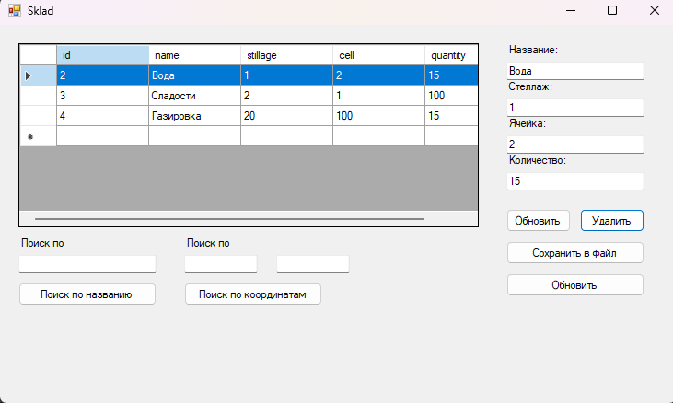

Рис.1. – Работа программы